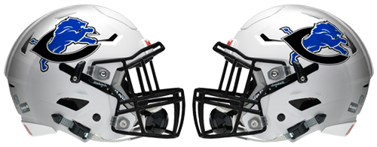

**2024**

**CLINT LIONS**

**VARSITY FOOTBALL TEAM**

***# Name Class Pos.***

1 Erick Martinez 12 RB/LB

2 Brandon Lopez 11 RB/DB

3 Samuel Brown 9 RB/DB

4 Brandon Quezada 11 QB/DB

5 Josue Huerta 12 RB/DB

6 Sebastian Villarreal 9 WR/DB

8 Isaac Rocha 11 RB/DB

9 Jose Arvizu 12 RB/DB

10 Ayden Martinez 11 WR/DB

11 Jesse Garcia 12 QB/DB

12 Sebastian Constanza 11 WR/DB

14 Kris Valenzuela 12 TE/LB

15 Xavier Ortega 10 WR/DB

20 Sean Phanid 12 WR/DB

21 Oliver Chavez 11 TE/DE

22 Angel Veliz 12 RB/DB

24 Joel Villagrana 12 WR/DB

25 Gabriel Perez 11 WR/DB

26 Jordan Rivera 9 RB/LB

28 Chris Rincon 11 RB/LB

30 Andres Retana 11 TE/DE

32 Lorenzo Medina 10 K/RB

35 Isaac Contreras 11 DE/RB

45 Anthony Banuelos 12 RB/DB

50 Alvaro Rosales 12 OL/DL

51 Johnny Rincon 12 OL/DL

54 Esteban Barrios 12 OL/DL

55 Isaiah Lopez 12 OL/DL

62 Jose Lopez 11 OL/DL

64 Angel Hernandez 12 OL/DL

68 Jayden Corral 12 OL/DL

72 Robert Villarreal 12 OL/DL

74 Raymond Herrera 11 OL/DL

75 Nick Lettunich 11 OL/DL

77 Edgar Regalado 10 OL/DL

84 Isaac Villanueva 12 WR/DE

**Head Coach**: Rosvel Martinez

**Off Coor**: John Wilson **Def Coor**: Jesus Lopez

**Asst:** David Gardea, Daniel Sanchez, Alex Valdez, Mike Ortega, Rogelio Hernandez, Juan Martinez, Armando Resendiz, Martin Renteria

**Trainers:** Carlos Arreola, Tim Weick

**Principal:** Dr**.** Garrett Ritchey

**Asst. Principals**: Mariaelena Mesquita, Mabel Garcia

**Athletic Director**: Mike Mackeben

**Superintendent**: Dr. Juan Martinez